



**Game Platform**: PC / **Smartphone**

**Target Age: 17 – 3**0 years

GAME SUMARY

**Hey! You’re a shark and the sea is on fire. Could be a great name for a song. Could be the literal PETROLEUM APOCALYPSE.**

**Escape rising flaming waters through your only way out, the sewer, and try to save your life as fast as you can while avoiding obstacles, such as shit n’ stuff**.

GAME OUTLINE

**As Mr. Shark, you’ll have to escape using your bite to hold on and swing from one tube to another until you find an exit. You’ll have to hurry or you’ll get (somehow) both soaked and turned into a crisp.**

**Avoid them shitty water flushes or they’ll make you sick. Consume mini zip-locks filled with a mysterious powder and get a strength boost.**

CONTROLS

**A D – Swing**

**W - Look up**

**Space (hold) – Grab tube**

**Space (release) – Let go**

**EscalaShark is a game where the player will play as a shark escaping from the flaming waters of the Gulf of Mexico through the sewer.**

**The objective in this game is to find the fastest way to an exit before being consumed in flames. Swing from a pipe to another measuring your impulse and timing, because you’ll die if you miss to grab on.**

**Avoid the obstacles spread across the sewer, such as intermittent doors that can black your way, or flushes of water that can push you away from safety.**

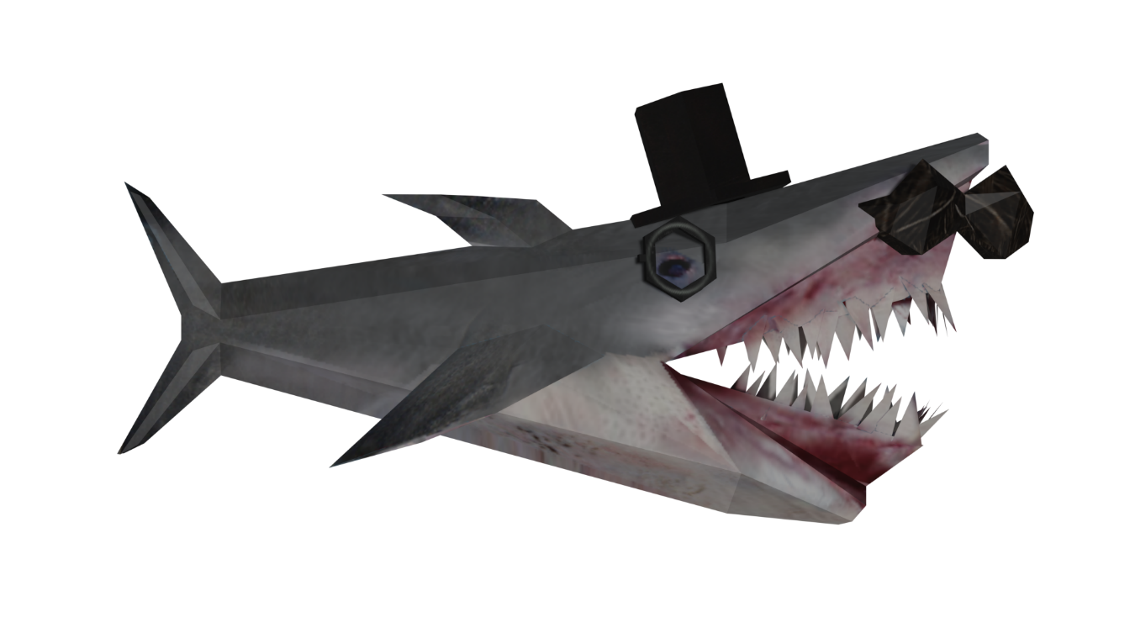Mr. Shark

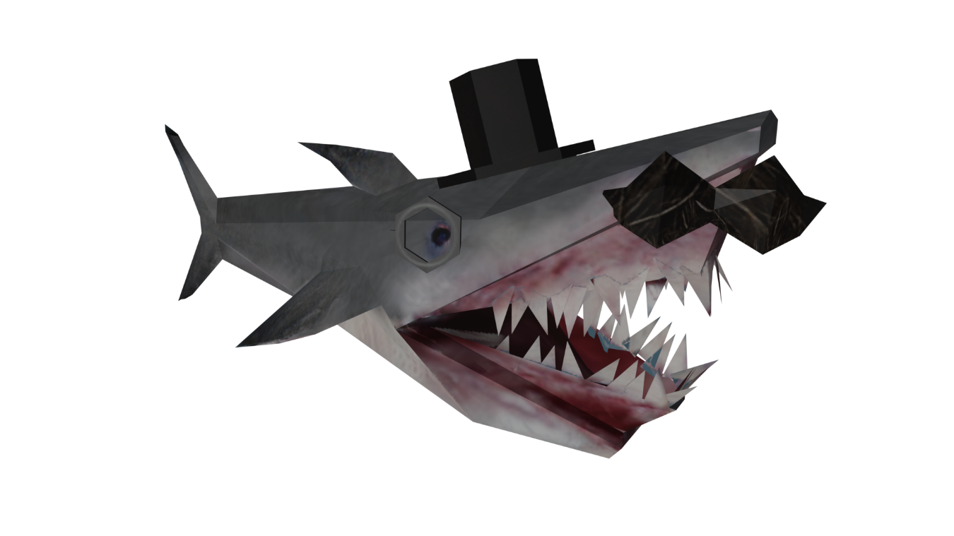

**Mr. Shark is a shark, and he is a man.**

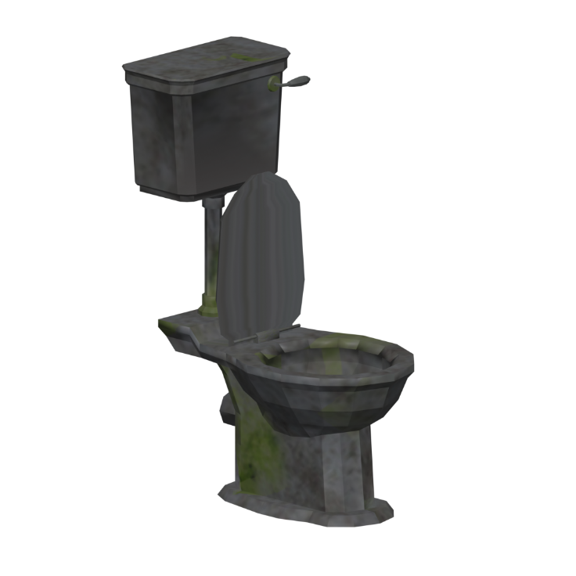Sewer

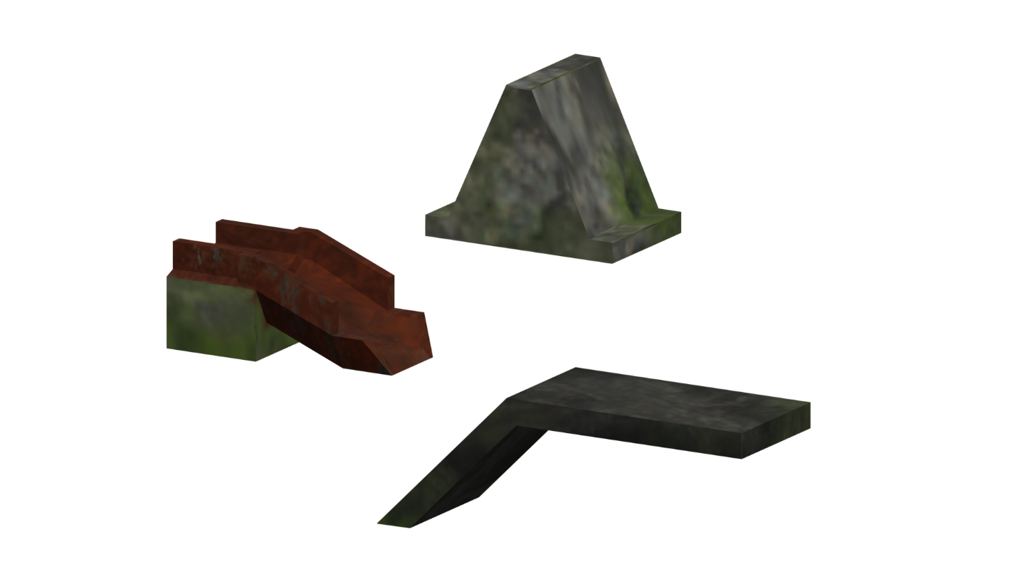

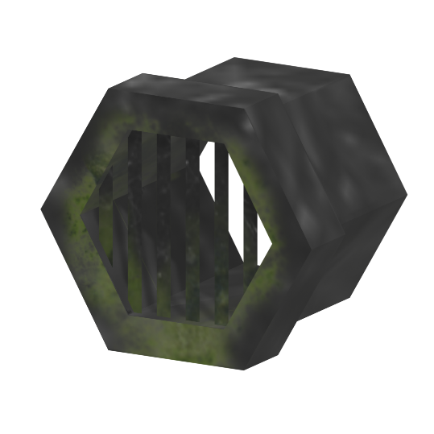

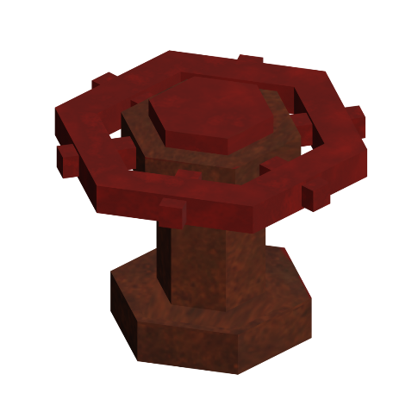

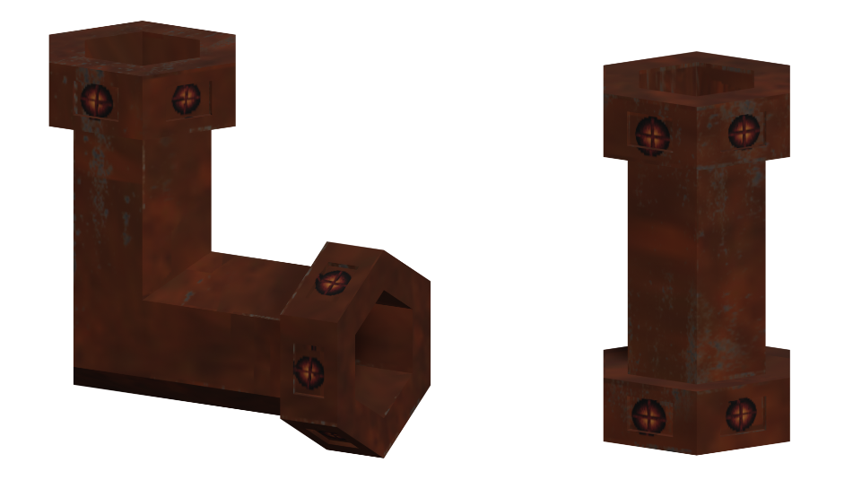

GAMEPLAY EXPERIENCE

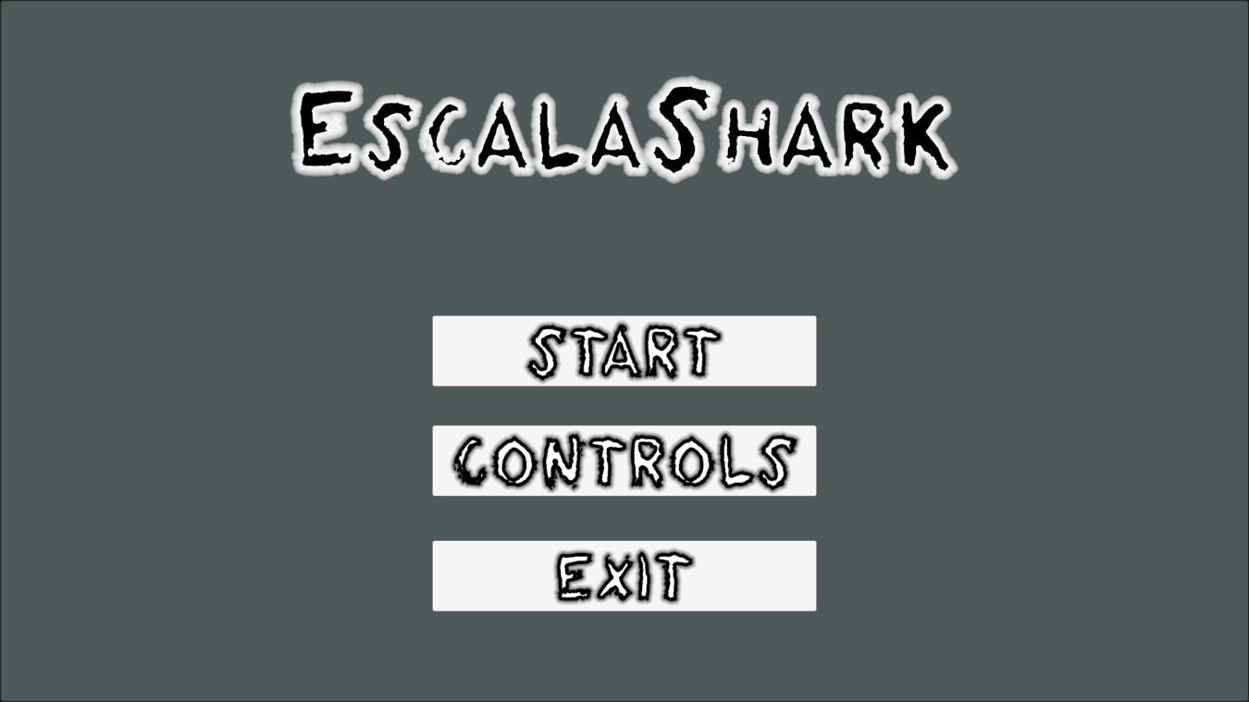

Main Menu

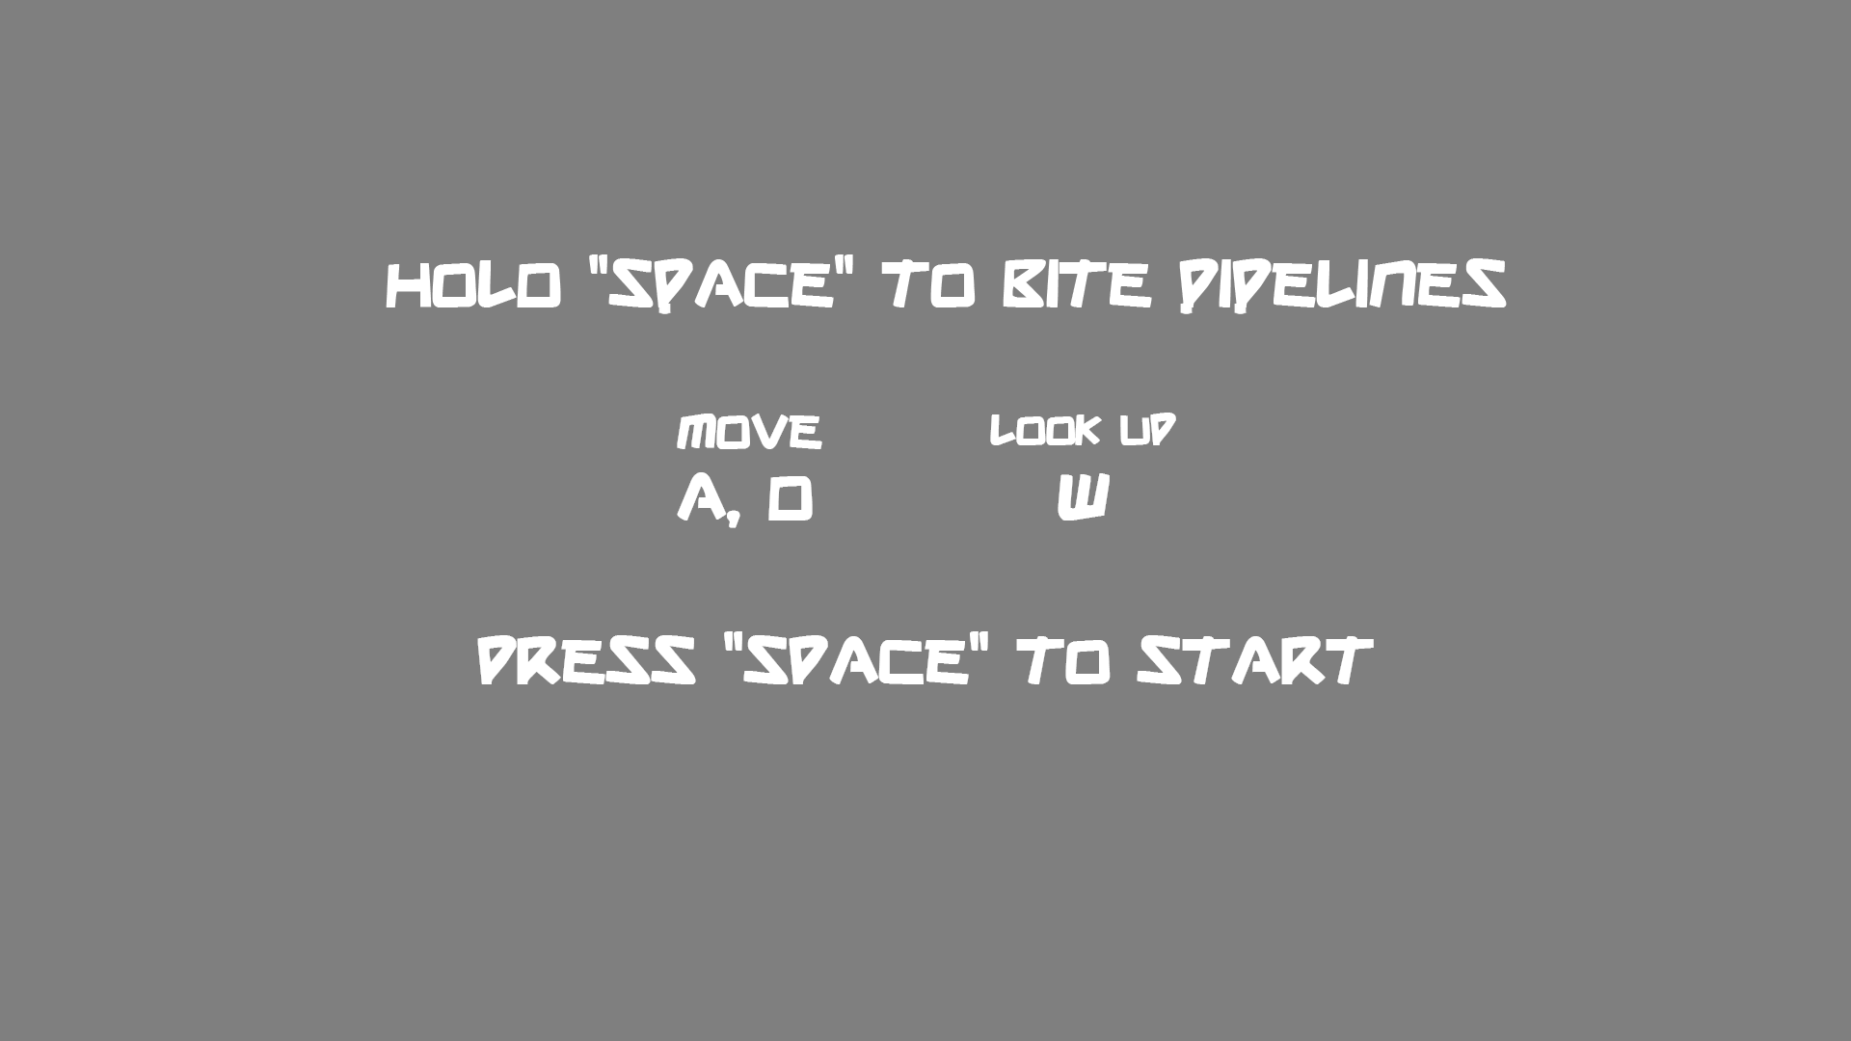

Controls Screen

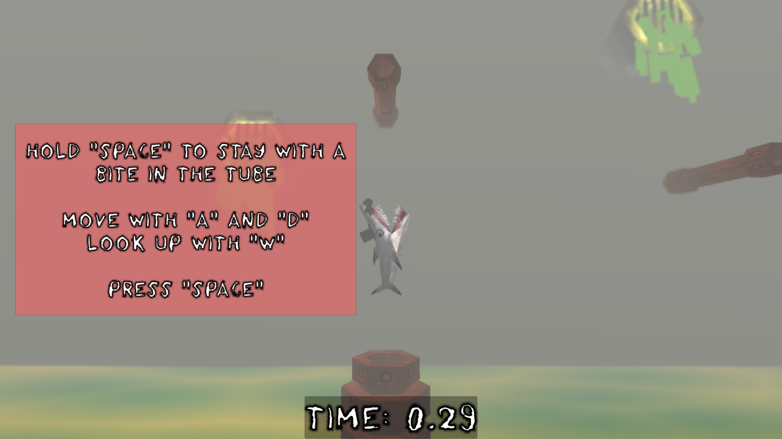

Game Start

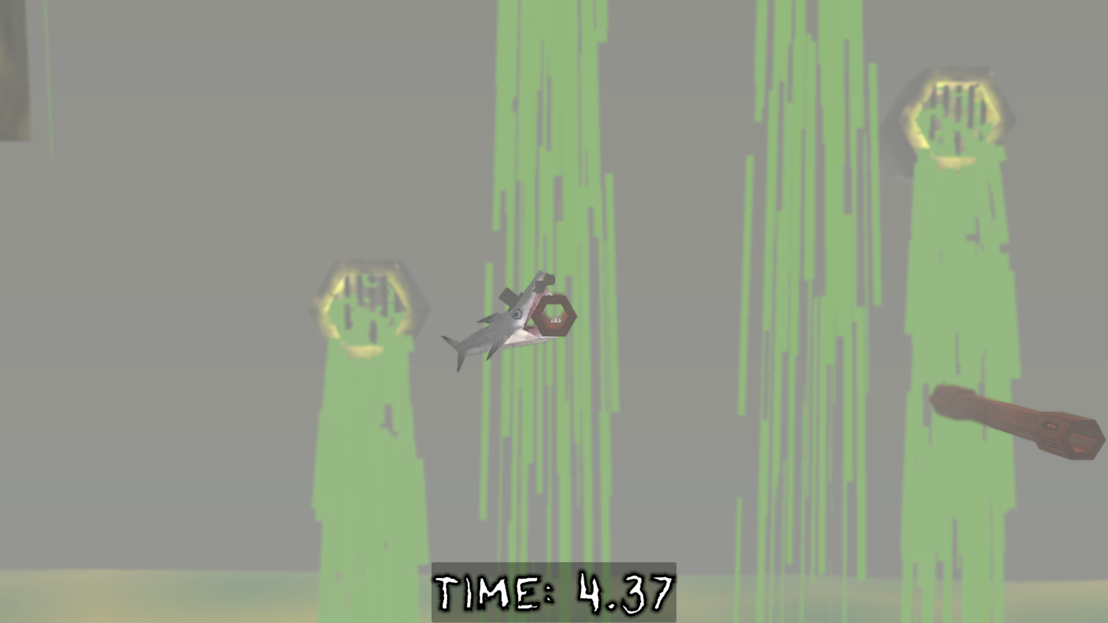

Gameplay



Game Over

AUDIO

**To craft the music, we wanted to contribute to the PS1 visual style by using VSTs with similar instruments and quality used and achieved in the 5th generation.**

**Scaling notes and a fast tempo were used in order to emulate the sensation of going upwards in a rush. An electric bass is the main instrument as its metallic sound reminds us of the pipes Mr. Shark swings at.**

**SFX were correspondently applied.**

**Some reverb was added to the whole mix so it sounds like it’s coming from inside the sewers.**

USP

* **Swing upwards from tube to tube**
* **Avoid obstacles**
* **Consume power-ups**

SIMILAR COMPETITIVE PRODUCTS

**- Getting Over It**

**- QWOP**

MANAGEMENT WEBS:

**Taiga: https://tree.taiga.io/project/misterflai-escalashark/**

**GitHub: https://github.com/Chuchoppert/EscalaShark**